## FINDING YOUR DATA STORY

1. **Introduction**

In this assignment, we will be visualizing using data visualization tools. We will be using a number based data-set from Kaggle containing data about the revenue generated on popular gaming platform Steam in the year 2024. Finally we will be comparing the tools in terms of capability and ease of use.

1. **Data Source**

The data-set used in this data visualization assignment is Top 1500 games on steams by Revenue in the year 2024 is available on Kaggle. The data-set is a number based data-set and mainly focuses on the top 1500 games which have performed very exceptional and had generated the best revenue.

1. **Creating Data Visualization using different Data Visualizationn tools**
2. Data Visualization using Zoho Analytics:

In our first tool we have used the tool Zoho Analytics to visualize the data. In this line chart, we have shown the revenue with blue color, tottal copies sold with ggreen color and total price with red color. By using this chart we can compare the revenue generated, total copies sold and the total price of the top 1500 games present in the dataset.

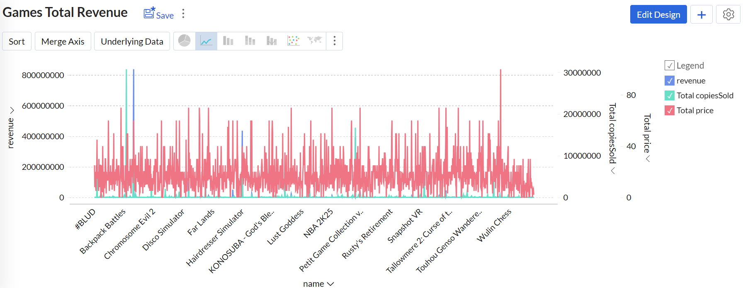

1. Data Visualization using Datawrapper:

For our second tool I have used Datawrapper. With this tool also many charts and graphs can be made using our current database. In this pie chart I have displayed that which games are responsible for the most amount revenue generation.

For example, Black Myth Wukong is responsible for the highest revenue generation and our other top 4 games include Helldivers 2, Palworld and Sons of the Forest in order.

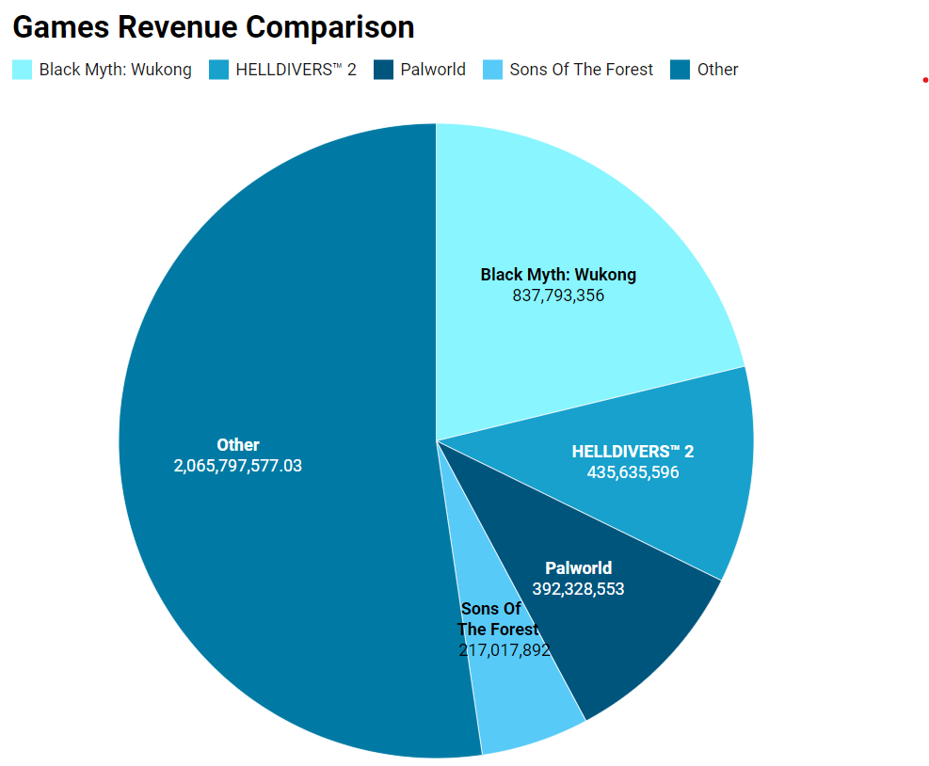

1. **Comparison in terms of Capability:**

### ****Datawrapper****

Datawrapper is a lightweight, user-friendly tool designed for creating clean and straightforward visualizations. It specializes in generating charts, maps, and tables that are highly customizable and embeddable, making it ideal for use in journalism, media, and web-based reporting. The tool supports basic chart types like bar charts, line charts, pie charts, scatter plots, and geographic visualizations. While Datawrapper excels in creating visually appealing and responsive graphics, it lacks advanced data manipulation and complex analytics capabilities, focusing instead on ease of use and accessibility for non-technical users.

### ****Zoho Analytics****

Zoho Analytics is a robust business intelligence and data analytics platform that offers advanced capabilities for data visualization, reporting, and analysis. It allows users to create a wide variety of visualizations, including dashboards, pivot tables, heatmaps, and complex chart types, making it suitable for business reporting and in-depth analysis. Zoho Analytics integrates well with a variety of data sources and includes features for data cleaning, preparation, and modeling. Its visualizations can be highly interactive, and the platform supports custom formulas, predictive analytics, and collaborative sharing, making it a more comprehensive tool for users who require both data analysis and visualization

1. **Comparison in terms of Ease of use:**

### ****Datawrapper****

Datawrapper is a highly intuitive and beginner-friendly data visualization tool designed for users who need quick, professional-looking charts with minimal effort. Its clean, minimalistic interface allows for fast creation of visualizations like bar charts, line graphs, and maps without the need for coding or technical expertise. While its customization options are basic, covering colors, labels, and fonts, it excels at making the chart creation process simple and straightforward. Datawrapper is perfect for users who prioritize speed and simplicity over advanced features and are looking for a tool that gets the job done efficiently.

### ****Zoho Analytics****

Zoho Analytics is a more feature-rich data analysis and visualization tool, offering a wide range of capabilities for users looking to perform in-depth data analytics and create complex, customizable visualizations. While it requires a moderate learning curve due to its extensive options, including advanced reporting, data blending, and SQL query support, it is a powerful tool for users who need flexibility and control over their data. The platform is ideal for intermediate to advanced users who need more than just basic chart creation, as it offers high customization and the ability to generate interactive dashboards and detailed reports.